PLEASE REPORT ISSUES AS SOON AS THEY HAPPEN

1. Use this button (1) as soon as an issue happens:

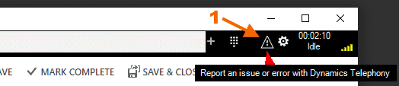

2. You can use Save for Sending Later button (2) if you do not have time now
for entering the other details.
Click the Report Issue button again later and fill in the details and click Send Now

